Name ___________________________________Period_____________ Date ______________________
Ms. Randall LE
Lab activity: Identifying Carbohydrates

Background: Carbohydrates are important organic compounds. They are the main energy sources of our diet. Carbohydrates contain three basic elements, (carbon, hydrogen, and oxygen). The ratio of hydrogen to oxygen in carbohydrates is the same as in water, (2: I). Carbohydrates can be categorized into three major groups. They are the simple sugars or monosaccharide’s, the double sugars or disaccharides, and the chains of sugars (starches) or polysaccharides.
A major task in biology is to identify and classify substances. This process is called qualitative analysis. There are two chemical tests that use laboratory indicators on carbohydrates to determine if they are monosaccharides, disaccharides, or polysaccharides. These two tests are the Benedict's test and the Iodine test.
Laboratory Indicators:
-Benedict solution; when heated with a monosaccharide turns from blue to green, yellow, orange, or red. It remains blue when heated with both disaccharides and polysaccharides. Therefore, it is used as a monosaccharide indicator.
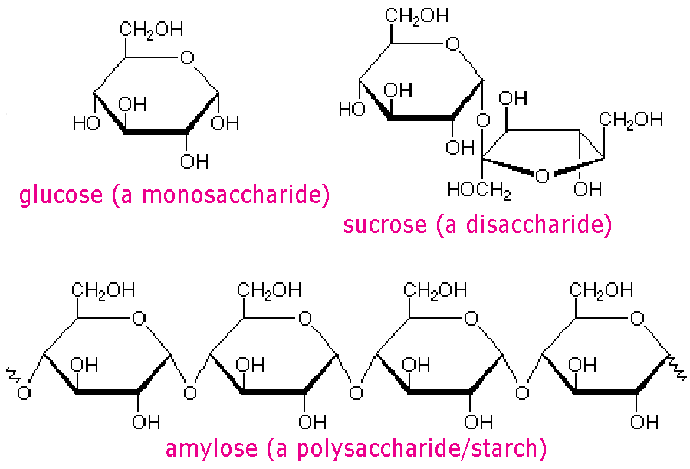
-Iodine solution; when mixed with a polysaccharide turns from rust to blue black. It remains rust when mixed with both monosaccharide and disaccharides. Therefore, it is used as a polysaccharide indicator.

Prelab:
- How is a polysaccharide different from a mono and disaccharide?____________________________ _________________________________________________________________________________
- Is Benedicts tests for the presence of a monosaccharide and Iodine tests for the presences of carbohydrates; how will you know if a disaccharide is present?________________________________ __________________________________________________________________________________
- Complete the table below to describe each laboratory indicator we will use today:
Name of Indicator | Tests for the presence of: | Positive Result looks…

Objectives:
- To determine the color change for carbohydrate indicators. Students will test samples of known carbohydrates to confirm color changes.
- To determine the category of carbohydrates various substances fall in. Students will test samples of unknown carbohydrates to determine if they are monosaccharides, disaccharides, or polysaccharides.
- Explain how Benedict’s solution and Iodine solution work as indicators.
- Describe how monosaccharides are combined to form disaccharides and polysaccharides.

Safety: You must wear goggles when working with heating test tubes.
Materials:

test tubes test tube racks
polysaccharide solution
droppers
hot plate
apple juice
water
beaker
Benedict’s solution
iodine
powdered sugar
disaccharide solution
table sugar
oats
monosaccharide solution
honey

Teacher Demo:

Record your observations in Table 1.
Data Table #1: Indicator Color Change for Known Carbohydrates:
Tube # | Type of Carbohydrate | Benedict’s Color | Iodine Color
1 | Monosaccharide
2 | Disaccharide
3 | Polysaccharide

Checkpoint for Understanding:
- When heated, Benedict’s Indicator solution turns____________________________ in the presence of _________________________.
- When heated, Iodine Indicator solution turns____________________________ in the presence of _________________________.

Procedure:
Having tested known carbohydrates, you are now ready to test some unknown substances. By comparing the results of the Benedict’s and iodine tests in Table 1, you should be able to classify substances as monosaccharide, disaccharide, or polysaccharide.

- Number 5 clean test tubes 1 to 5. Add the following to each tube:

- Tube 1: 20 drops of honey
- Tube 2: 20 drops of liquid oats (use a clean dropper)
- Tube 3: 20 drops of table sugar solution (use a clean dropper)
- Tube 4: 20 drops of apple juice (use a clean dropper)
- Tube 5: 20 drops of powdered sugar solution (use a clean dropper)

- Add 30 drops of Benedict’s solution to each test tube.
- Place all 5 tubes in the hot water bath for 5 minutes
- Remove the test tubes from the bath with a test tube holder and notes any color changes. Record the color of the solutions in Table 2.

2. Prepare 5 more test tubes containing the substances just used (honey, oats, etc.) Do NOT add benedict’s solution!

- Add 4 drops of iodine to each test tube and mix by swirling.
- Note any color changes and record in Table 2.
- On the basis of your results, classify each carbohydrate as a monosaccharide, disaccharide, or polysaccharide and record your answers in Table 2.

Data Table #2: Indicator Color Change for Unknown Carbohydrates:
Sample | Benedict’s Color | Iodine Color | Name this type of Carbohydrate
Honey
Oats
Apple
Table Sugar
Powdered Sugar

Analysis: Please answer the questions in complete sentences.
- If a certain sugar has no color change when tested with Benedict's solution, can you tell what type of saccharide it is? Explain your answer. __________________________________________________ __________________________________________________________________________________
- If a certain sugar has no color change when tested with iodine, can you tell what type of saccharide it is? Explain your answer. ________________________________________________________________ __________________________________________________________________________________
- If a certain sugar has a color change when tested with Benedict's solution, can you tell what type of saccharide it is'? Explain your answer. ___________________________________________________ __________________________________________________________________________________
- If a certain sugar has a color change when tested with iodine, can you tell what type of saccharide it is? Explain your answer. _________________________________________________________________ ___________________________________________________________________________________
- If a certain sugar has no color change with either the Benedict’s solution test or the iodine test, can you tell what type of sugar it is? Explain your answer. __________________________________________ __________________________________________________________________________________
- Does the human diet contain many foods consisting only of one type of saccharide? Explain your answer. ____________________________________________________________________________ ___________________________________________________________________________________

