Name:__________________________________________Period:_____Date:______
Ms. Randall Marine Science
Hydrothermal Vents

Do Now:

- Draw and describe what the ocean floor looks like.

- What do you known about under water volcanoes?

Design an animal that is adapted to live on the seafloor by a divergent plate boundary (work in pairs, but each person should turn in a worksheet). Sketch your animal and explain at least 3 adaptations it has for dealing with its environment.

Think first about what conditions on the seafloor are like. What kind of environment is it? How might the environmental conditions be a challenge to an animal’s survival?

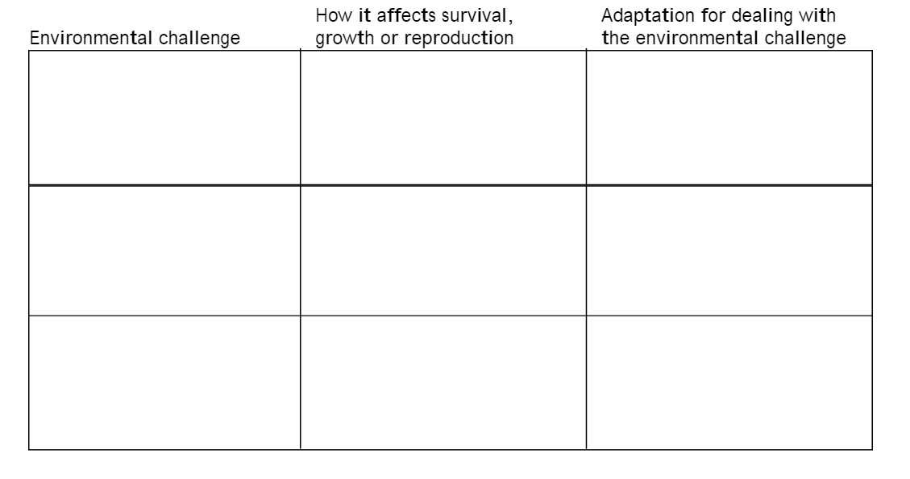

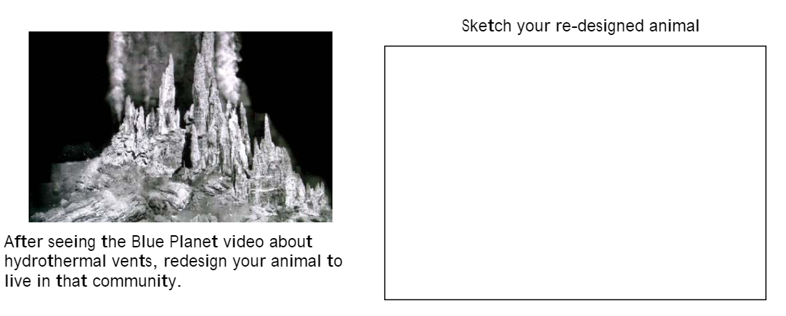

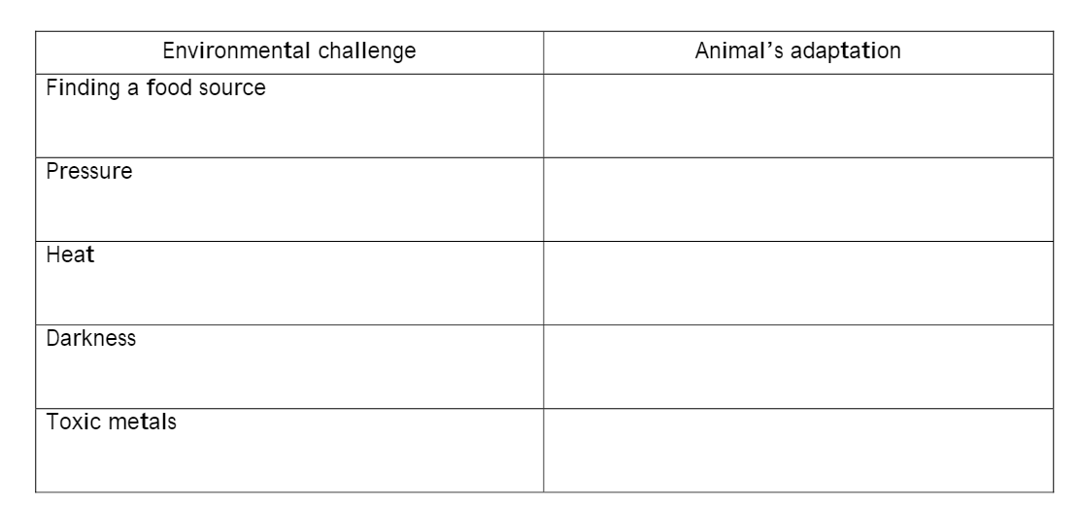

After seeing the Blue Planet video about hydrothermal vents, redesign your animal to live in that community. Look back at your drawing of the ocean floor. Has your perspective changed about what the ocean floor looks like? The animals that live on the ocean floor?

Give 3 specific examples of what you have learned or how your perspective has changed.

